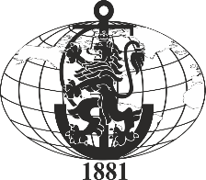 | ВИСШЕ ВОЕННОМОРСКО УЧИЛИЩЕ „Н. Й. ВАПЦАРОВ“  9002 Варна, ул. „В. Друмев“ 73, тел.052/632-015, факс 052/303-163
 | “FILII MARIS SUMUS”
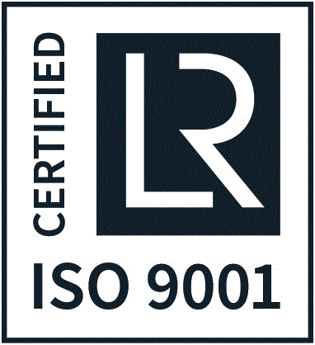

ERASMUS POLICY STATEMENT
- Rationale and Focus
The Nikola Vaptsarov Naval Academy (the Academy) has a strategy of long-term cooperation with partners from the business and academia. The Academy takes all the necessary measures to ensure that its graduates have the required knowledge and skills in variety of engineering, managerial and maritime areas, and will also be able to implement their skills in the work place. This is the trade-mark of the Academy, and its entire academic and administrative staff is strongly devoted to it.
Our partners are selected on the basis of common professional fields (of maritime business, education and management), and the abilities to establish mutual fruitful cooperation based on mutual trust and transparency of activities and quality, as well as common goals in academic and business proficiency.
Most of our partners are from the European region, following the strong support of EU in the inter-institutional cooperation at a European level. In addition to that, the Academy is a member of the International Association of Maritime Universities, which includes maritime universities and academies from around the world. This allows us to have close contacts with partners in Asia, USA, Canada, Australia and the Middle East. The Black Sea region is also a focal point for us, having in mind our geographical location.
Our mobility activities are aimed at students during their time of studies, as well as at academic staff in either stage of career development. Most of the students who take advantage of those practices are ones in their bachelor studies, although there are also Master students. The Academy is active in developing modern curricula in highly attractive areas, keeping active industry and academic links and timely informing students of the possibilities to diversity their studies and to visit other academic institutions abroad.
The participation in the ERASMUS+ programme has a strong impact on the quality of education and professional competence at the Academy. Through these programmes, our students are in the position to go ahead, acquire valuable experience in their area of studies, and eventually ensure their career development after graduation. Lectures are in the position to exchange good practices in the area of teaching, improve their abilities to work in an inter–cultural environment, improve their language proficiency and meet other academics from their research area.
- Policy pathways
The Academy is planning to increase the number of staff involved in the ERASMUS+ programme, in order to be able to cover forthcoming challenges in the international area. There are several aspects, where the Academy shall seek pathways of development within the ERASMUS+ programme:
- Intensify its ERASMUS+ activities in the student-mobility-for-study space;
- Initiate training at leading industries for graduates of the Academy, eventually under the calls of the Key Action 2;
- Prepare, particulate and/or coordinate more ERASMUS MUNDUS projects in order to cooperate academically and scientifically with HEIs from various non-EU regions in the world;
- Expand student mobility for students during their PhD programmes;
- Initiate specialized language courses to support outgoing students and staff under the ERASMUS+ measures;
- Link staff mobility for teaching with work performance and career development of staff focusing on improved teaching skills, and use of blended delivery techniques;
- Diversify the student cohort of Academy through incoming students following cooperation on various key actions of ERASMUS +;
- Improve language training and teaching skills by stimulating participation in advanced specialized language courses, training programmes, sessions and workshops on innovations in teaching and learning and blended delivery.
- Policy impact
We expect to see direct impact on the modernization of the institution thanks to the participation in the ERASMUS+ programme in the following:
- Intensified cooperation with leading industry partners and key players in the maritime business and engineering arena in an international scale;
- Education process that is coordinated and adjusted to latest trends and demands in maritime education and training, management and maritime engineering;
- Strong cooperative links across the academic community in the higher education space in Europe and beyond;
- Cooperation with stakeholders, policy makers and the wider community in the area of maritime transport, management, engineering and training;
- Maintaining and improving high performance of academic staff;
- Keeping the trade-mark of the Academy, which is to prepare well-trained specialists with excellent professional potential for all areas of maritime business.

