APPLICATION FORM

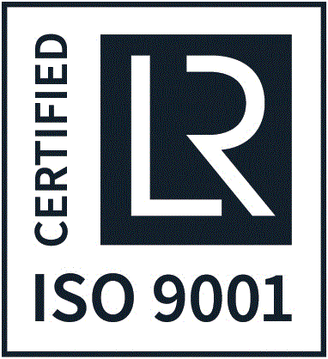 Academic year 2021/2022

REPUBLIC OF BULGARIA
NIKOLA VAPTSAROV NAVAL ACADEMY PHOTOGRAPH
73 Vasil Drumev Str.
9002 Varna
Tel.: + 359 52 632 015
Fax: + 359 52 303 163
E-mail: info@naval-acad.bg

Specialty: 1__________________________________________________________________
2. _________________________________________________________________
3. _________________________________________________________________
4. _________________________________________________________________

Language of tuition (underline): Bulgarian, English

I. Personal data
Family name: .................... First name: ..................................……...
Gender (male/female) .............. Date of birth:..........................................
Place of birth: .................. Nationality: .............................................
Postal address: .........................................................………….................................
.......................................................................................…………...........………
Zip code .................... Country ............................……………….......
Phone (mobile) …………………………………………………………………………….
E-mail: ……………………………………………………………………………………...

II. Education background
School: .................................................................………………………………………
Years ............................. City: .........................................……...…..........
Certificates and dates of issue: ..................................................................................….
..................................................................................……………………………….
Diploma results: .............................................................

III. Proficiency in foreign languages
Native language............................................ Bulgarian ..........................................................
English .......................................... Other (specify)...................................................
Please indicate: excellent, good, satisfactory

IV. I undertake to submit the following documents upon admission to the Naval Academy:
1. Copy of the Certificate for completion of secondary education (high school) and the Supplement (academic transcript) together with its translation in Bulgarian certified by the Ministry of Education and Ministry of Foreign Affairs in Applicant's country and registered at the Bulgarian Embassy in Applicant's country (original stamps and seals).
2. Document issued by school authorities which certifies that the applicant is allowed to proceed to tertiary (university) education in the country where the secondary education has been accomplished together with translation in Bulgarian both duly legalized.
3. Medical Health Certificate Original (valid 1 month) registered at the Ministry of Foreign Affairs in Applicant's country and registered at the Bulgarian Embassy in Applicant's country (original stamps and seals).
4. Photocopy of personal identification document (passport).
5. Original document for financial support translated in Bulgarian both duly legalized.
6. Six (6) photographs 3.5/4 cm size.
7. Certificate of proficiency in English (B2 or higher).

This application is under art.95 par.(8) of the Law of Higher Education of Republic of Bulgaria

Date:...................................... Signature:....................................

